From: <http://www.bloomberg.com/features/2015-cloud-seeding-india/>

Weather on Demand: Making It Rain Is Now a Global Business

Welcome to the strange world of cloud seeding.

By Amanda Little | October 28, 2015

Photographs by Philippe Calia for Bloomberg Businessweek

From

“Most pilots are trained to avoid these storm systems,” shouts Byron Pederson. “We’re trained to enter them.” He’s flying a King Air B200 prop jet above Maharashtra, India, toward a dense, bruise-colored monsoon cloud more than 20,000 feet from top to bottom. He dips a wing, *Top Gun*-style, as he circles the cumulonimbus. “Bank alert!” warns a computerized female voice from the control panel. Pederson calls her Bitchin’ Betty for all the scolding she does as he defies the generally accepted rules of aviation.

Four of us are crammed inside the tiny plane, and the air smells like stress and sweat. Pederson’s in the cockpit with Shahzad Mistry, the rookie co-pilot he’s training; I’m seated a few feet behind them, trying not to vomit on the fridge-size computer to my right that’s humming and blinking as it records meteorological data. To my left is Prakash Koliwad, chief executive officer of Kyathi Climate Modification Consultants, the cloud-seeding company based in Bangalore that commissioned this flight.

The view outside my window goes smoky gray as Pederson maneuvers the King Air inside a dark layer of heavy moisture along the cloud’s underbelly. The plane lurches and shakes. “We’re in,” says Pederson. The Vertical Speed Indicator on the dashboard climbs. We’ve entered the “updraft,” a shaft of wind at the center of all storm clouds that’s sucking the plane upward at a rate of 800 feet per minute. I can barely lift my hands—the G-force is pinning them to my lap.

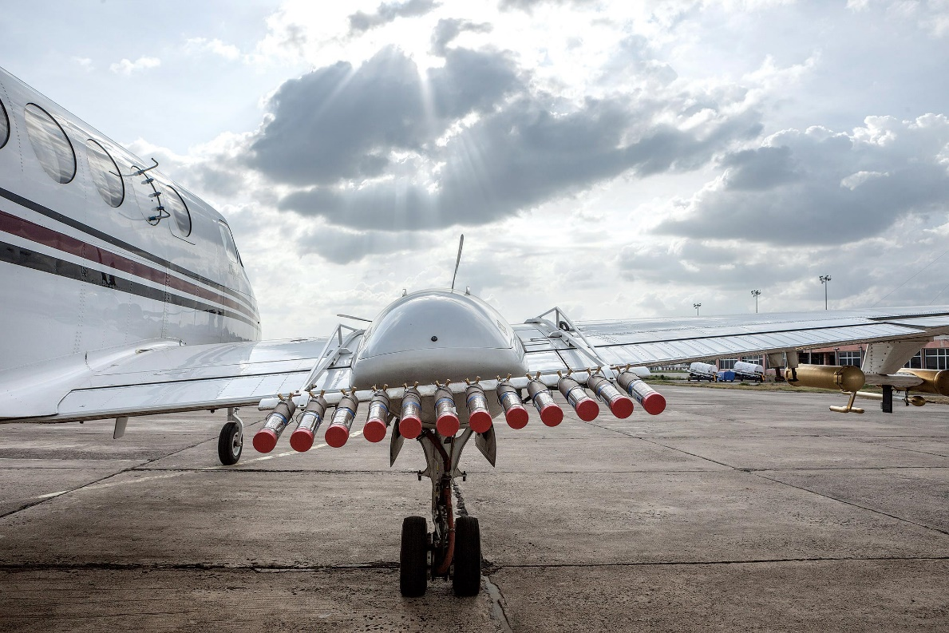

Combustible sodium chloride flares.

Photographer: Philippe Calia for Bloomberg Businessweek

“Fire left,” instructs Pederson. Mistry flips a switch on the center console and deploys a flare on the left wing. “Fire right.” There are 24 cylinders resembling sticks of dynamite wired to racks on the plane’s wings, 12 on each. The flares are filled with combustible sodium chloride—pulverized table salt mixed with a flammable potassium powder. When the switch is flipped, the end of the flare shoots orange fire and trillions of superfine salt particles are released into the cloud. Water molecules are attracted to salt, so they bond to the particles and coalesce into raindrops.

It’s early September, still monsoon season in this southwestern region of India, yet the clouds haven’t done much more than drizzle. Maharashtra is one of the largest and wealthiest of India’s 30 states, with 110 million residents. It encompasses Mumbai and other large cities, plus vast swaths of farmland. Like other agricultural regions of India, it’s in its third consecutive year of drought. More than 80 percent of its farms depend on rain for irrigation, and agriculture production [has dropped](http://www.bloomberg.com/news/articles/2015-09-07/dry-weather-seen-shrinking-sugar-output-in-india-s-top-producer) by almost a third since 2013. The human impact has been severe—1,300 debt-trapped farmers have [committed suicide](http://www.bloomberg.com/news/articles/2015-02-04/india-farmer-suicides-on-rise-as-cotton-slump-spurs-debts) in Maharashtra in just the past six months.

In July, the state’s minister of revenue, Eknath Khadse, took a gamble: He hired Koliwad to carry out a $4.5 million cloud-seeding program over three months and across 100 square miles in the middle of the state, the largest campaign of this kind ever attempted in India. “Our situation is severe,” says Khadse. “There is no other technology available in the world to bring more rains. We must be willing to try it.”

So Koliwad called Weather Modification Inc., the world’s largest private aerial cloud-seeding company, based in Fargo, N.D. WMI’s chief executive, Patrick Sweeney, developed a five-year technology transfer program with Koliwad that’s now in its first year. Pederson and other WMI staff are training Indian pilots, meteorologists, and Doppler radar technicians to seed clouds.

Sweeney has seeded clouds all over the world for more than 20 years, but the Maharashtra project is unique in that the circumstances are so dire. “The hardest part is managing expectations,” he says. “People in Maharashtra are hoping for a cure-all to drought. They come out and dance in the streets when it rains, they hug our pilots and say, ‘Do it again.’ But we can’t guarantee that the clouds will be there—and willing to cooperate.”

During our mission over Maharashtra, we have cooperative clouds. Twenty-two minutes after seeding the first cloud, Pederson returns to the location where he fired that initial flare. It’s pouring. “We’ve got drops!” he shouts. He dips the King Air into a victory swoop before gunning over to another cluster of clouds. My stomach churns, and I can’t hold it in any longer; I heave into my purse. Pederson doesn’t notice. The computer barks out another warning about excessive banking. He laughs and says, “Shove it, Betty.”

Maharashtrians drawing water from a well.

Photographer: Philippe Calia for Bloomberg Businessweek

Cloud seeding has been controversial since it was invented by Vincent Schaefer in 1946. A chemist for General Electric, Schaefer made the first snowstorm in a laboratory freezer. The media predicted that cloud seeding could perform miracles, from dousing forest fires to ensuring white Christmases. But doubts quickly arose about the impact of meddling with nature. Concerns that cloud seeding might “steal” water from an area a cloud is traveling toward—robbing Peter to water Paul, as it were—have been dispelled. Storm clouds continually regenerate and release only a portion of their moisture when they rain, which means you can’t “wring out” all the moisture from one cloud. “If anything, the area downwind would get more precipitation from cloud seeding, not less,” says Dave Reynolds, a meteorologist with the National Oceanic and Atmospheric Administration.



Setting up the cloud-seeding flares.

Photographer: Matthew Hintz for Bloomberg Businessweek



Silver iodide, ready to be deployed.

Photographer: Philippe Calia for Bloomberg Businessweek

“There’s little dispute that if you can actually get the seeding material inside the clouds, it will enhance precipitation,” says Dan Breed, a scientist with the National Center for Atmospheric Research. “The question is, by how much?” Just as it’s hard to predict the weather, it’s hard to really know if you’ve made it rain or not. Breed’s own research—a nine-year, $14 million government-funded study he completed last year in collaboration with WMI and the University of Wyoming—found that seeding increased snowfall 5 percent to 15 percent from clouds in two Wyoming mountain ranges.

In India, I witnessed “hygroscopic” or water-attracting cloud seeding, which is used in warm-weather regions to enhance rain, disperse fog, and clean dirty skies. Breed’s study examined the cold-weather seeding of “orographic” clouds that form above high-altitude mountains and deliver snow. This method, which is used during winters in [arid](http://www.bloomberg.com/politics/articles/2015-05-11/drought-transcends-state-lines-as-u-s-west-turns-ever-more-arid) western U.S. states, fills rivers and water reservoirs in the spring when the snow melts. Snow-enhancement projects are often commissioned by water managers and power companies with hydroelectric plants; for decades, Pacific Gas & Electric has spent millions annually on cloud seeding in the Sierra Nevadas.

Cold-weather seeding is done at the core of snow clouds that can reach altitudes as high as 60,000 feet: Flares filled with tiny flakes of silver iodide are ejected into the clouds’ centers. Silver iodide has a molecular structure similar to that of ice. As the silver particles drift down through the clouds, water gloms onto them as it would to ice, and snowflakes grow.

This method is also routinely used for mitigating hail storms, especially in Canada: When silver iodide particles are injected into a hail-producing storm cloud, there are suddenly more nuclei for the ice to cling to. Smaller ice pellets, or “graupel,” form rather than large hail stones.

Silver iodide in large concentrations can be harmful, but the concentrations found in snowpack after cloud seeding are often so low as to be undetectable. Breed’s NCAR study in Wyoming found that there was less silver iodide in snow and soil samples in areas where clouds had been seeded than there had been before the campaigns—either due to fluctuations in naturally occurring levels of silver iodide or because the extra water released by the seeding flushed the system.

Just as it’s hard to predict the weather, it’s hard to really know if you’ve made it rain or not

It’s easier to measure the success of snow seeding than rain seeding, but Reynolds of the NOAA points out that even the results from snowstorm studies vary significantly. “The data is still pretty sparse,” he says. “There are very few absolutes in cloud science. What we do know is that no two clouds are alike.” This makes it difficult to control and replicate the results of cloud-seeding studies.

Despite the uncertainty, the industry is on the rise. According to the World Meteorological Organization, more than 52 countries have active cloud-seeding operations—up from 42 four years ago. In the U.S. last year, 55 cloud-seeding projects were reported to NOAA. There’s even a luxury cloud-seeding market emerging—one European company, for instance, charges a minimum of $150,000 to guarantee good wedding weather by forcing clouds to rain in the days before the event.

“The scientists want 100 percent certainty—we know in our industry from experience that, most of the time, it works,” says Koliwad. The cost of cloud seeding is negligible compared with that of drought, he adds. The Maharashtra government has spent $750 million to defray the impact of drought over the last three years; cloud seeding costs a fraction of that. “Rain is life,” says Koliwad, whose family has farmed in southwestern India for more than 300 years. “And with climate change, rain is becoming less reliable. If we can monitor it, forecast it, manage it, and enhance it—then we can survive.”

The plane takes off for cloud-seeding operations.

Photographer: Philippe Calia for Bloomberg Businessweek

The man who’s brought cloud seeding to 31 countries on six continents works out of an unassuming airfield in North Dakota. Patrick Sweeney is 63, with thick silver hair and the compact build of a wrestler. There’s an air of J.R. Ewing about him—the confidence of a wildcatter-turned-mogul. Since he got his pilot’s license in 1974, he’s flown more than 6,000 hours of cloud-seeding expeditions. He looks low-key, driving his Chevy pickup in jeans and sunglasses, but he also owns a pair of Learjets and an amphibious plane that he takes to his compound on Bad Medicine Lake in Minnesota.

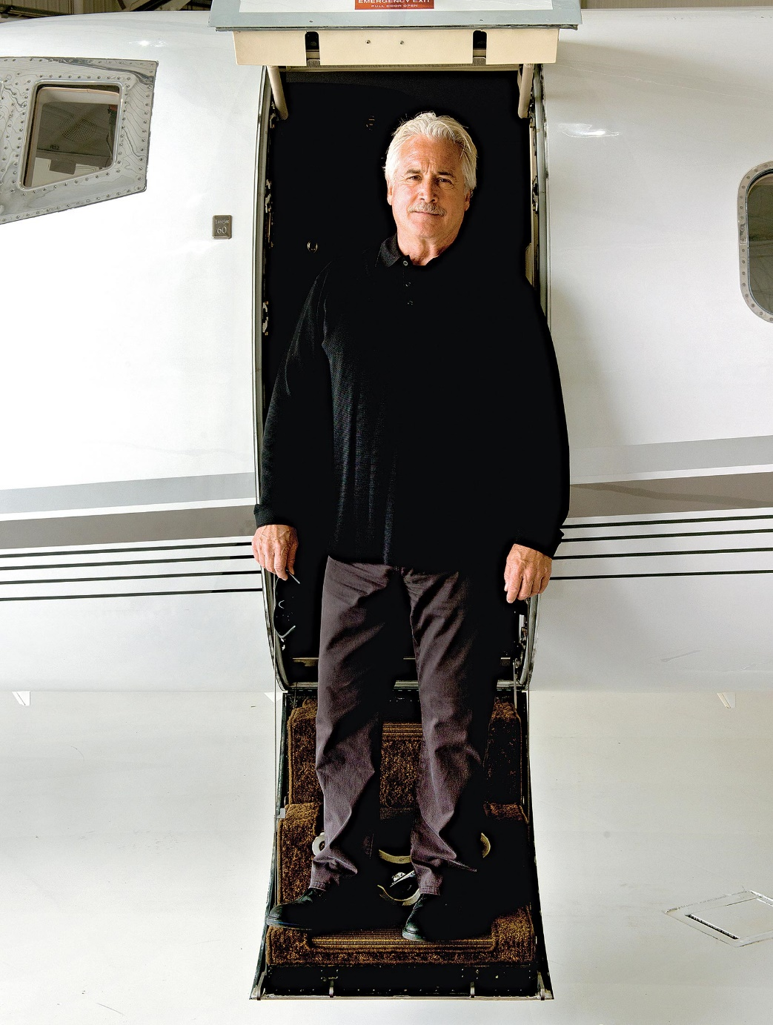

Sweeney aboard one of his Learjets.

Photographer: Matthew Hintz for Bloomberg Businessweek

Sweeney is optimistic about the India project, but he cautions that what he does isn’t a short-term solution for drought. “This industry should be seen as long-term water management—not a drought relief deal,” he says. “If you don’t have clouds, you can hire all the cloud seeders in the world and you’re still not going to have rain.” Still, a lot of people are eager to hire him for a variety of projects: WMI, which generates roughly $20 million a year in revenue, is negotiating contracts with governments in Asia, South America, and the Middle East that could double its revenue in 2016.

As a kid, Sweeney reassembled radios for fun. He’s been working in meteorology since he was 18, when he joined the Navy and went to Vietnam, specializing in weather radar. When he enrolled at the University of North Dakota after the war, he started building advanced Doppler radars in the university’s department of atmospheric sciences. At 27 he was hired as WMI’s third employee by Wilbur Brewer, a North Dakota farmer who became interested in cloud seeding as a means to protect his crops from hail damage. At 34, Sweeney bought out Brewer and made WMI an international business.

Since then he’s built a series of multifaceted companies. WMI is located at the Fargo Jet Center—a private airport Sweeney owns with his brother, Jim. Hundreds of private planes fly in and out each year, many stopping to refuel as they ferry clients on international travel (the jet center has a famously expedient customs office). This is also where Sweeney’s mechanics equip and service the more than 100 WMI cloud-seeding aircraft—Cessnas, King Airs, and Bombardiers—they operate or have leased and sold worldwide.

Sweeney also built ICE (Ice Crystal Engineering), a company that makes cloud-seeding chemicals and supplies flares to 25 countries. ICE adds a decent sidestream of income for Sweeney, with revenue of about $3 million a year. But the bigger advantage is that it helped WMI become the only aerial seeding company that “does a full turnkey,” says Neil Brackin, WMI’s president—meaning it customizes and operates the planes and radars, manufactures the flares, and flies the missions.

They do have competitors. There are 34 private companies worldwide that do weather modification, but there’s no bigger rival in aerial cloud seeding than the Chinese government, which spends hundreds of millions a year seeding clouds in 22 of its 23 provinces, both to clear pollution above cities and to enhance rainfall for farming. China has yet to allow private companies to enter its market, but Sweeney is making inroads; he sold his first cloud-seeding plane to Beijing last year.

Thailand’s government has a Bureau of Royal Rainmaking, with hundreds of employees that WMI helped train, though the program’s still using old technology—releasing mounds of table salt from trap doors in the bellies of its planes. And when the Argentine government took over the cloud-seeding program WMI built for the country, it cut costs. Soon after, two pilots died seeding clouds above a mountain, and the project was suspended.

Sweeney says plenty of programs around the world are mismanaged or nothing more than short-term vanity projects. “Some are doing weather modification for political reasons, to make it look like they’re helping farmers, then they cut corners and don’t maintain the scientific integrity,” he bristles. “That’s what creates distrust in our industry more than anything else—the people who don’t do it right.”

The disaster management headquarters in Aurangabad.

Photographer: Philippe Calia for Bloomberg Businessweek

The office of disaster management in Aurangabad, at the center of Maharashtra’s farming region, is located in a pale-pink building that looks like a wedding cake. What especially draws the eye isn’t the building’s color or the ornate façade but the weird thing on the roof—a huge white orb, about 80 feet in diameter, on top of a scaffolded tower. This is the latest in Doppler radar, a technology that’s improved significantly over the last decade, along with satellite data and computing power. It helps the government make sure it’s getting its money’s worth.

The orb sends out electromagnetic waves that travel hundreds of kilometers; when the waves hit rain droplets and ice crystals, they bounce back and create an image of the cloud contour. The stronger the signal, the denser the cloud and the more intense the rain. Conventional radars send out only horizontal waves, but the new generation of radars has a dual-polarization system that emits vertical and horizontal waves, enabling meteorologists to get 3D images of the interior of the cloud to see how the precipitation is developing and at what rate. The resolution of its images has increased with improved computing power. In recent years, software known as Titan (Thunderstorm identification, tracking, and nowcasting) interprets and visualizes radar data in real time, feeding it to meteorologists as pilots seed the clouds. Weather Research & Forecasting software is also able to model future storm activity with increasing accuracy.



Cloud-seeding flares.

Photographer: Matthew Hintz for Bloomberg Businessweek

“The combination of these things has given cloud-seeding research a tremendous push in the past 10 years,” says Roelof Bruintjes, a scientist at NCAR, “and we’ll see it redouble in the next decade.”

“The better we can see weather, the better we can model it,” adds WMI’s Brackin, “and the better we can then measure the impact of the seeding.”

Maharashtra’s minister of revenue, Khadse, is happy with the results of the first phase of the cloud-seeding effort. It produced 950 millimeters of rainfall in the seeded areas, according to local officials. “It has been enough to keep some of our crops alive,” he says. “But we understand that a project like this can only succeed over a longer duration.” His director of disaster management, Suhas Diwase, plans to move the program out of his department, which is designed to handle short-term troubleshooting. “We can’t think of this as a one-time deal,” Diwase says. Given this longer view, cloud seeding doesn’t have to succeed 100 percent of the time—it’s enough for it to work part of the time, when the clouds decide to cooperate.

NCAR’s Breed explains that this long-term mentality is the reason water managers and hydroelectric plant operators in the western U.S. have invested in cloud seeding over many decades: No matter how variable the weather is, “a 5 percent increase in snowpack from cloud seeding over time is pretty doable. Water managers are perfectly happy with 5 percent—even if they don’t get 15 percent, it’s still economical.”

Brackin adds that while scientists want to achieve a 99.99 percent probability that a technology consistently works, the industry doesn’t need that kind of certainty or consistency to succeed. He likens cloud seeding to a cutting-edge medication that’s still in development: “If you’re dealing with a serious ailment and you were offered a medicine that had a 60 percent chance of working, or even 20 percent, would you take it? You probably would.”